VIVA Header - LM35 Temp Sensor

5 Aug. 2017 | Nolan Manteufel

# Schematic

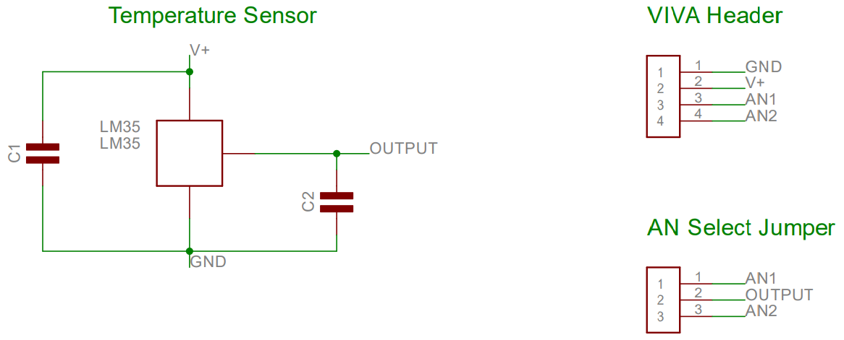

# Layout

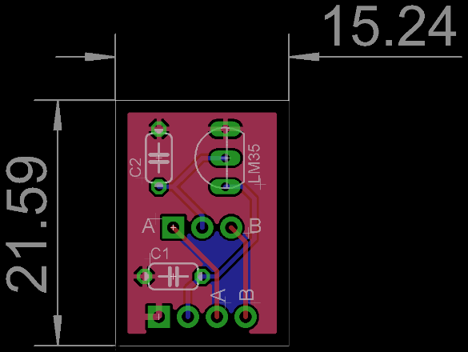

Dimensions in mm